# TITLE PAGE

**DESIGN AND IMPLEMENTATION OF A FOOD ORDERING SYSTEM  
(CASE STUDY OF AMAZI EATERY, FEDERAL POLYTECHNIC, MUBI)**

**BY**

**BASHERU USENI MUHAMMAD**

**(ST/CS/HND/21/053)**

**DEPARTMENT OF COMPUTER SCIENCE,**

**SCHOOL OF SCIENCE AND TECHNOLOGY,**

**FEDERAL POLYTECHNIC, MUBI, ADAMAWA STATE.**

**IN PARTIAL FULFILLMENT OF THE REQUIREMENT FOR THE AWARD OF HIGHER NATIONAL DIPLOMA (HND) IN COMPUTER SCIENCE.**

**SEPTEMBER, 2023**

# DECLARATION

I hereby declare that the work in this project titled **“Design and Implementation of a Food Ordering System (case study of Amazi Eatery, Federal Polytechnic, Mubi)”** was performed by me under the supervision of Mal. Yayirus Garba. The information derived from literatures has been duly acknowledged in the text and a list of references provided. The work embodied in this project is original and had not been submitted in part or in full for any other diploma or certificate of this or any other institution.

Basheru Useni Muhammad ________________ _______________

(ST/CS/HND/21/053) Signature Date

# CERTIFICATION

This project titled **“Design and Implementation of a Food Ordering System (case study of Amazi Eatery, Federal Polytechnic, Mubi)”** meets the regulations governing the award of Higher National Diploma (HND) in Computer Science, Federal Polytechnic Mubi, Adamawa State.

Mal. Yayirus Garba __________________

(Project Supervisor) Sign/Date

Mr. Mustapha Kassim __________________

(Head of Department) Sign/Date

Mal. Abdulrahman Saidu __________________

(External Examiner) Sign/Date

# DEDICATION

This project is dedicated to my beloved parents for their advice, encouragement and financial support towards my academic pursuit.

# ACKNOWLEDGEMENTS

I want to acknowledge Almighty God for his infinite mercy and protection throughout my academic activities. And for the understanding in achieving our academic success.

I also recognize my Supervisor Mal. Yayirus Garba who took time, despite his busy schedule to direct and guide me throughout this research work.

I also acknowledge the Head of Department Computer Science Mal. Mustapha Kassim for his moral encouragement throughout my period of study. I also acknowledge all Staff of Computer Science Department for their support and encouragement and the knowledge they’ve impacted on me throughout my studies.

I also want to appreciate my lovely parents for their love and care and for giving me the opportunity to be trained and achieve my dreams.

Finally, I appreciate the efforts of my Uncles and aunties, for their encouragement and support throughout the course of my study and also my friends and relatives, course mates and all well-wishers. I love you all, may the Almighty God bless you abundantly, Amen.

# TABLE OF CONTENTS

TITLE PAGE i

DECLARATION ii

CERTIFICATION iii

DEDICATION iv

ACKNOWLEDGEMENTS v

TABLE OF CONTENTS vi

LIST OF FIGURES viii

LIST OF TABLES ix

ABSTRACT x

CHAPTER ONE 1

INTRODUCTION 1

1.1 Background to the Study 1

1.2 Problem Statement 2

1.3 Aim and Objectives 2

1.4 Significance of the Study 2

1.5 Scope of the study 2

1.6 Definition of some Operational Terms 3

CHAPTER TWO 4

LITERATURE REVIEW 4

2.1 Introduction 4

2.2 Food Ordering Systems 4

2.2.1 Benefits of Food Ordering Systems 4

2.2.3 Types of Food Ordering Systems 5

2.3 User Experience and Interface Design 5

2.4 Order Processing and Integration 6

2.5 Operational Efficiency and Resource Utilization 6

2.6 Customer Satisfaction and Loyalty 6

2.6.1 Factors Affecting Customer Satisfaction 6

2.6.2 Measuring Customer Satisfaction 7

2.6.3 Customer Loyalty 7

2.6.4 Importance of Customer Loyalty 7

2.6.5 Strategies to Enhance Customer Loyalty 7

2.7 Emerging Trends and Technologies 8

2.8 Review of Related Literatures 8

CHAPTER THREE 10

SYSTEM DESIGN AND ANALYSIS 10

3.1 Introduction 10

3.2 Disadvantages of the Existing System 10

3.4 The Proposed Method 11

3.5 Method of Data Collection 11

3.6 System Design 11

3.6.1 Algorithm Diagram 12

3.6.3 Database Tables/Queries Structures 13

3.6.4 Entity Relationship Modelling 15

3.6.5 Database Entity Relationship Diagram 15

3.6.6 Input and Output Design 16

3.6.7 Report Layout 17

3.7 System Requirement Specification 18

3.7.1 Hardware Requirements 18

3.7.2 Software Requirements 18

3.7.3 Personnel Requirement 18

CHAPTER FOUR 19

RESULTS AND DISCUSSION 19

4.1 Introduction 19

4.2 Results 19

4.3 Discussion 22

4.4 User Manual 23

CHAPTER FIVE 24

SUMMARY, CONCLUSION AND RECOMMENDATIONS 24

5.1 Summary 24

5.2 Conclusion 24

5.3 Recommendations 24

5.4 Contribution to Knowledge 25

5.5 Area for Further Work 25

REFERENCES 26

APPENDICES 28

# LIST OF FIGURES

Figure 3.1: Use case diagram 12

Figure 3.2: Activity Diagram for Online food ordering system 13

Figure 3.2: System Architecture 13

Figure 3.3: Entity Relationship Modelling 15

Figure 3.4: Entity Relationship Diagram 15

Figure 3.5: Registration Form 16

Figure 3.6: Login form 16

Figure 3.7: Order Form 16

Figure 3.8: Payment Form 17

Figure 3.9: Ordered Item 17

Figure 4.1: Login interface 19

Figure 4.2: Admin Dashboard 19

Figure 4.3: Ordered Food Interface 20

Figure 4.4: Food Menu Interface 20

Figure 4.5: Payment Gateway Interface 21

Figure 4.6: Ordered Request Interface 21

Figure 4.7: Customer Registration Interface 22

# LIST OF TABLES

Table 1: Food Table 13

Table 2: Users table 14

Table 3: Orders Table 14

# ****ABSTRACT****

*The rapid evolution of digital technology and the changing landscape of the foodservice industry have compelled eateries and restaurants to adapt to new methods of serving their customers efficiently. This research project presents the comprehensive design and successful implementation of a Food Ordering System tailored specifically for Amazi Eatery, located within the Federal Polytechnic, Mubi. The primary objective of this system is to enhance the food ordering and delivery process, streamline operations, improve customer experience, and maximize operational efficiency. The Food Ordering System comprises a user-friendly interface for customers to place orders, an order management system for restaurant staff, and integration with a delivery service. Through rigorous development and testing, the system has been fine-tuned to ensure seamless and secure transactions. Additionally, it allows for menu customization, real-time order tracking, and feedback collection from customers. The findings of this project underscore the transformational potential of such systems in the foodservice industry. The successful implementation of this Food Ordering System at Amazi Eatery demonstrates the adaptability of technology in catering to the demands of a dynamic and competitive industry. It sets a precedent for the efficient delivery of food services, marking a significant stride towards enhancing customer experience and operational excellence in the foodservice sector.*

*.*

# CHAPTER ONE

# INTRODUCTION

## 1.1 Background to the Study

In today's fast-paced world, the food industry is undergoing a significant transformation, driven by advancements in technology and changing consumer preferences. Restaurants and eateries are increasingly adopting innovative solutions to improve operational efficiency, enhance customer experience, and stay competitive. One area of focus is the implementation of food ordering systems, which streamline the ordering process and enable seamless interaction between customers, restaurant staff, and kitchen operations. The food industry is constantly evolving, and technological advancements have significantly influenced the way restaurants and eateries operate. One area that has experienced notable transformation is the ordering process, with the introduction of food ordering systems. These systems utilize digital platforms and mobile applications to streamline the ordering process, enhance customer experience, and improve operational efficiency in the restaurant industry (Roberts & Brown, 2023).

Online food ordering is the process of ordering food from a website. The product can either be

food that has been specially prepared for direct consumption (such as vegetables straight from a

farm or garden, frozen meats, etc.) or food that has not been (such as direct from a certified home-

kitchen, restaurant). The effort to create an online food ordering system aims to replace the manual

method of taking orders with a digital one (Hwang & Ryu, 2017).

In recent years, there has been a significant shift in consumer behavior, with an increasing number of people preferring online and mobile ordering options. According to a survey conducted by Statista (2022), online food delivery sales reached $32.81 billion in the United States in 2021, indicating the growing popularity of digital ordering platforms. Restaurants and eateries need to adapt to these changing trends to remain competitive and meet customer expectations. Traditional manual ordering processes, characterized by handwritten notes or verbal orders, often resulted in errors, miscommunications, and longer waiting times. These inefficiencies led to customer dissatisfaction and posed challenges for restaurant staff in managing high-demand periods effectively. In response, the implementation of food ordering systems has gained traction as an effective solution to these issues.

Amazi Eatery presents an opportunity to explore the implementation and evaluation of a food ordering system in a real-world context. Amazi Eatery, a prominent restaurant chain, identified the need to address challenges related to order management, customer satisfaction, and operational efficiency. The manual order processing methods resulted in delays, order inaccuracies, and customer dissatisfaction. To overcome these challenges, Amazi Eatery embarked on a project to implement a robust food ordering system tailored to their specific requirements

## 1.2 Problem Statement

Amazi Eatery, a popular restaurant chain, has been facing challenges related to order management, customer satisfaction, and operational efficiency. The traditional manual ordering process has resulted in inefficiencies, order inaccuracies, and long waiting times, leading to customer dissatisfaction and potential revenue loss. To address these issues, there is a need for an effective food ordering system that can streamline operations, improve order accuracy, and enhance the overall dining experience.

## 1.3 Aim and Objectives

The aim of this project is to design and implement a food ordering system at Amazi Eatery, focusing on the following specific objectives:

1. To identify the challenges faced by Amazi Eatery in its current order management process.
2. To design and develop a comprehensive food ordering system that caters to the specific needs of Amazi Eatery.
3. To design a secure system where order records of Amazi eatery can be kept and retrieved when needed.

## 1.4 Significance of the Study

The implementation of an efficient food ordering system at Amazi Eatery has significant implications for both the restaurant industry and customers. For the restaurant, it offers the potential to enhance operational efficiency, reduce costs, and improve revenue generation.

Helping customers in placing meal orders whenever they want. Customers will be able to order their preferred foods at any time, but as we've already mentioned, this is only a limited option.

Additionally, it enables better order management, resulting in increased customer satisfaction and loyalty. For customers, the system provides a convenient and seamless ordering experience, reducing waiting times and ensuring order accuracy.

## 1.5 Scope of the study

The scope of the study is involves developing a food ordering system for Amazi Eatery. The food ordering system provides search options based on various criteria such as food item, customer, order, and order confirmation. This feature allows customers and restaurant staff to easily locate specific information within the system, enhancing efficiency and convenience. The online food ordering system includes functionalities to manage payment information, order details, order confirmation, and food items online. It ensures secure transaction handling and simplifies the payment process for customers, leading to a seamless ordering experience. The system displays comprehensive information and descriptions of food items for customers. It facilitates effective management of food items and categories, allowing easy editing, adding, and updating of records. This feature enables Amazi Eatery to provide up-to-date and accurate information to customers, enhancing their decision-making process.

## 1.6 Definition of some Operational Terms

**Data Management:** The process of organizing, storing, and manipulating data within the food ordering system. It involves managing customer information, order details, menu items, and other relevant data (Brown & Wilson, 2023).

**Delivery fee:** A delivery fee refers to the additional charge or cost associated with the delivery of goods or services to a designated location (Merriam Webster Dictionary, 2022).

**Food Item Display:** The feature of the food ordering system that presents detailed information and descriptions of food items to customers. This functionality ensures accurate and up-to-date information is available to customers (Jones & Anderson, 2023).

**Food Ordering System:** A software application or platform that enables customers to browse menus, select food items, customize orders, and place orders electronically from restaurants or eateries (Johnson & Smith, 2022).

**Order Tracking:** The capability of the food ordering system to track and manage the entire order process. It provides real-time updates on the status of orders, allowing customers to monitor their orders from placement to delivery or pickup. This functionality ensures efficient order management and coordination between the kitchen, restaurant staff, and customers (Smith & White, 2023).

**Payment Processing:** It securely manages customer payment information, verifies transactions, and provides confirmation details. This functionality ensures a seamless and secure payment process for customers (Davis et al., 2023).

**Search:** Functionality within the food ordering system that allows users to search for specific information based on various criteria such as food item, customer, order, and order confirmation. This feature enables users to quickly locate relevant data and enhances efficiency in navigating the system (Roberts & Brown, 2023).

# CHAPTER TWO

# LITERATURE REVIEW

## 2.1 Introduction

This chapter provides a comprehensive review of the existing literature on food ordering systems, focusing on their design, implementation, and impact on the food service industry. The review examines recent studies and articles to identify best practices and emerging trends relevant to the design and implementation of a food ordering system at Amazi Eatery.

## 2.2 Food Ordering Systems

Food ordering systems have gained significant attention in recent years, revolutionizing the way customers interact with restaurants and facilitating the ordering process. These systems can be classified into various types, including web-based applications, mobile applications, and self-service kiosks (Li et al., 2021).

Web-based applications, such as the one proposed for Amazi Eatery, offer convenience and accessibility across different devices (Li et al., 2021). They enable customers to browse menus, customize orders, and make payments online. Mobile applications, on the other hand, provide additional flexibility and location-based services, allowing customers to place orders on-the-go (Wang et al., 2020).

In Roshan (2017), an automated food ordering system is proposed which will keep track of user orders smartly. Basically, they implemented a food ordering system for diﬀerent type of restaurants in which user will make order or make custom food by one click only. By means of android application for Tablet PCs this system was implemented. The front end was developed using JAVA, Android and at the backend MySQL database was used. Customer using a Smartphone is considered as a basic assumption for the system. When the customer approach to the restaurant, the saved order can be conﬁrmed by touching the Smartphone. The list of selected pre-ordered items shall be shown on the kitchen screen, and when conﬁrmed, order slip shall be printed for further order processing. The solution provides easy and convenient way to select pre-order transaction form customers.

## 2.2.1 Benefits of Food Ordering Systems

Food ordering systems offer numerous benefits to both customers and restaurant owners.

For customers, these systems provide convenience and flexibility in the ordering process. They eliminate the need for customers to physically visit the restaurant or wait in long queues to place an order (Wu et al., 2021). Customers can easily browse menus, view item details, customize their orders, and make payments online from the comfort of their homes or offices (Ma et al., 2022). Mobile applications further enhance convenience by allowing customers to order food on-the-go, providing location-based services and personalized recommendations (Wang et al., 2020).

For restaurant owners, food ordering systems improve operational efficiency and customer reach. These systems automate the order-taking process, reducing manual errors and minimizing the need for human intervention (Chen et al., 2020). They enable efficient order processing and management, with real-time order confirmation and payment processing, leading to reduced waiting times and improved customer satisfaction (Huang et al., 2019). Food ordering systems also provide valuable data and analytics, offering insights into customer preferences, order patterns, and popular menu items. This information can inform decision-making regarding menu optimization, targeted marketing campaigns, and inventory management (Li et al., 2021). Moreover, online platforms and mobile applications expand the customer base for restaurants, attracting tech-savvy customers and increasing brand visibility (Kumar *et al*., 2020).

## 2.2.3 Types of Food Ordering Systems

Food ordering systems can be classified into different types based on their platforms and interfaces. Common types include web-based systems, mobile applications, self-service kiosks, and third-party platforms.

Web-based systems, accessed through web browsers, provide a user-friendly interface for customers to browse menus, select items, customize orders, and make payments (Li et al., 2021).

Mobile applications offer a dedicated platform for customers to place food orders using their smartphones or tablets. They provide additional features such as location-based services, push notifications, and personalized recommendations (Wang et al., 2020).

Self-service kiosks are physical terminals placed within or outside the restaurant premises. Customers can use these touch-screen kiosks to browse menus, place orders, and make payments independently (Chen et al., 2020).

Third-party platforms act as intermediaries between restaurants and customers, hosting multiple restaurant listings and providing a unified platform for customers to discover and order food from various establishments (Ma et al., 2022).

## 2.3 User Experience and Interface Design

User experience (UX) and interface design play a crucial role in the success of a food ordering system. A well-designed interface should be intuitive, visually appealing, and user-friendly (Chen et al., 2020). It should enable customers to easily navigate through menus, view item details, and customize orders. Personalization features, such as recommendations based on past orders or dietary preferences, can further enhance the user experience (Huang et al., 2019).

## 2.4 Order Processing and Integration

Efficient order processing is essential for a seamless food ordering system. Studies have explored various aspects of order processing, including order confirmation, payment processing, and order status updates. Automation of these processes minimizes errors, reduces waiting times, and improves overall customer satisfaction (Ma et al., 2022).

Integration with existing restaurant operations is another important consideration. Seamless integration with inventory management systems allows real-time tracking of ingredient availability and prevents customers from ordering unavailable items (Kumar et al., 2020). Integration with kitchen operations facilitates smooth order flow and coordination between the front-of-house and back-of-house staff (Wu et al., 2021). Moreover, integration with customer service systems enables efficient handling of inquiries and feedback (Zhang et al., 2021).

## 2.5 Operational Efficiency and Resource Utilization

Food ordering systems can significantly improve operational efficiency and resource utilization for restaurants. Automation of repetitive tasks, such as order taking and payment processing, reduces manual errors and frees up staff time (Ma et al., 2022). Efficient routing algorithms for order delivery can optimize delivery routes and minimize delivery time (Chen et al., 2020). Additionally, data generated by the system, such as customer preferences and order patterns, can inform decision-making for menu planning, marketing strategies, and inventory management (Li et al., 2021).

## 2.6 Customer Satisfaction and Loyalty

Food ordering systems have a direct impact on customer satisfaction and loyalty. Studies have shown that a seamless and convenient ordering process leads to higher customer satisfaction levels (Huang et al., 2019). Features like order history tracking, personalized recommendations, and loyalty programs can further enhance customer loyalty and encourage repeat business (Wang et al., 2020).

Research has consistently shown the positive correlation between customer satisfaction and the success of food ordering systems. A study by Luo et al. (2019) found that higher customer satisfaction leads to increased customer retention and positive word-of-mouth, resulting in a larger customer base.

## 2.6.1 Factors Affecting Customer Satisfaction

Several factors contribute to customer satisfaction in food ordering systems:

a) Ease of Use: The system should have a user-friendly interface, intuitive navigation, and clear instructions to ensure a seamless ordering process (Li et al., 2021).

b) Order Accuracy: Accurate order processing, including correct item selection, customization, and delivery details, is crucial to meet customer expectations (Wu et al., 2021).

c) Delivery Speed: Timely delivery plays a significant role in customer satisfaction. Efficient logistics and delivery management contribute to a positive customer experience (Huang et al., 2019).

d) Customer Support: Responsive and helpful customer support, whether through chatbots, phone assistance, or email, is essential to address customer inquiries, concerns, or complaints promptly (Chen et al., 2020).

e) Personalization: Tailoring the system to individual customer preferences, such as personalized recommendations or customized offers, enhances customer satisfaction (Zhang et al., 2021).

## 2.6.2 Measuring Customer Satisfaction

To assess customer satisfaction, various methods can be employed:

a) Surveys: Customer satisfaction surveys, conducted online or through mobile applications, provide insights into customer perceptions, preferences, and areas for improvement (Ma et al., 2022).

b) Ratings and Reviews: Customer ratings and reviews on the system's platform or third-party review sites offer valuable feedback and help identify areas of strength or weakness (Wang et al., 2020).

c) Net Promoter Score (NPS): NPS measures customer loyalty and willingness to recommend the system to others. It helps gauge overall customer satisfaction and loyalty (Kumar et al., 2020).

## 2.6.3 Customer Loyalty

Customer loyalty refers to the commitment and repeat patronage of customers towards a food ordering system. Loyal customers not only provide consistent business but also serve as brand advocates, promoting the system to others.

## 2.6.4 Importance of Customer Loyalty

Customer loyalty has significant implications for the success and profitability of food ordering systems. Research by Li et al. (2021) reveals that loyal customers are more likely to spend more, try new menu items, and recommend the system to others. They contribute to a higher customer lifetime value, resulting in increased revenue and market share.

## 2.6.5 Strategies to Enhance Customer Loyalty

Several strategies can be employed to enhance customer loyalty:

a) Rewards and Incentives: Implementing a loyalty program that offers rewards, discounts, or exclusive offers for repeat customers can incentivize loyalty and encourage repeat business (Wu et al., 2021).

b) Personalized Communication: Sending personalized emails, notifications, or offers based on customer preferences and order history helps foster a sense of individual attention and strengthens customer loyalty (Huang et al., 2019).

c) Social Media Engagement: Actively engaging with customers on social media platforms, responding to their comments, and running interactive campaigns create a sense of community and foster loyalty (Zhang et al., 2021).

d) Seamless Experience: Ensuring a seamless and consistent experience across different platforms and touchpoints, such as web and mobile applications, contributes to a positive customer experience and strengthens loyalty (Chen et al., 2020).

## 2.7 Emerging Trends and Technologies

Emerging technologies are being integrated into food ordering systems, enhancing their capabilities and improving user experiences.

Artificial Intelligence (AI) and Machine Learning (ML) algorithms are employed to personalize the ordering experience by analyzing customer preferences, order histories, and demographics. These algorithms can suggest relevant items, offer personalized recommendations, and predict customer preferences (Wu et al., 2021).

Chatbots and virtual assistants are used to automate customer interactions and provide instant support. They can handle common inquiries, assist with menu recommendations, and even process orders through conversational interfaces (Zhang et al., 2021).

Internet of Things (IoT) devices can be integrated into food ordering systems to enhance operational efficiency. Smart kitchen appliances and sensors can automate inventory tracking, monitor food quality, and optimize cooking processes (Huang et al., 2019).

Blockchain technology is being explored for secure and transparent transactions in online food ordering systems. It can ensure secure payments, prevent data tampering, and enable reliable reviews and feedback (Kumar et al., 2020).

## 2.8 Review of Related Literatures

Numerous studies have examined the factors influencing customer satisfaction and loyalty in food ordering systems. Liu and Li (2020) conducted a study on online food delivery platforms and found a positive relationship between customer satisfaction and loyalty. They highlighted the importance of meeting customer expectations and providing a seamless ordering experience.

Chen, Cai, and Zhou (2018) focused on mobile food ordering apps in China and identified various factors that determine customer satisfaction. They found that factors such as app usability, order accuracy, delivery speed, and customer support significantly impact customer satisfaction levels.

In a study by Nguyen and Nguyen (2020) in Vietnam, they explored the factors influencing customer satisfaction and loyalty in third-party food delivery apps. Their findings revealed that factors like food quality, delivery speed, order accuracy, and customer service significantly influenced customer satisfaction and loyalty.

Jang and Namkung (2009) conducted a study on the restaurant industry, applying the extended Mehrabian-Russell model. They found that perceived quality, emotions, and behavioral intentions were interconnected, and customer satisfaction played a crucial role in determining behavioral intentions.

Hwang and Ryu (2017) focused on quick-casual restaurants and investigated the influence of food quality, service quality, and price on customer satisfaction and behavioral intention. They also explored the moderating role of perceived hygiene factors. Their findings indicated that food quality, service quality, and price significantly influenced customer satisfaction and behavioral intentions, and perceived hygiene factors played a moderating role in the relationship.

Overall, these studies highlight the importance of factors such as ease of use, order accuracy, delivery speed, customer support, food quality, and service quality in influencing customer satisfaction and loyalty in food ordering systems. Understanding these factors can help businesses improve their systems and enhance customer experiences, ultimately leading to increased satisfaction, loyalty, and positive word-of-mouth.

**2.9 Summary**

This chapter reviewed the existing literature on food ordering systems, highlighting their design, implementation, and impact on the food service industry. The review emphasized the importance of user experience, order processing, integration with existing systems, operational efficiency, customer satisfaction, and emerging trends. The insights gained from this review will serve as a foundation for the design and implementation of a food ordering system at Amazi Eatery.

# CHAPTER THREE

# SYSTEM DESIGN AND ANALYSIS

## 3.1 Introduction

This chapter contains the system design and analysis that was employed to achieve the aim of the project. In this chapter, we present the design and implementation details of the food ordering system at Amazi Eatery. The system aims to provide a seamless and efficient experience for customers to place orders, manage their preferences, and facilitate smooth operations for the restaurant staff. We will discuss the overall system architecture, database design, user interfaces, and the integration of various components.

## 3.2 Disadvantages of the Existing System

The manual system for food ordering, which typically involves handwritten order forms or verbal communication between customers and restaurant staff, has several disadvantages. These disadvantages highlight the need for an automated food ordering system like the one implemented at Amazi Eatery. Manual systems are prone to human errors such as misinterpreting handwritten orders, incorrect entry of order details, or miscommunication between staff members. These errors can lead to order inaccuracies, delays, and customer dissatisfaction.

The manual system relies on physical paperwork or verbal communication, which can be time-consuming and prone to delays. Customers may have to wait in long queues to place their orders or experience delays due to order processing inefficiencies. This inefficiency can result in longer waiting times, decreased customer satisfaction, and potential revenue loss for the restaurant. Paper-based order forms can be easily misplaced or lost, leading to order confusion or even complete loss of orders. This can be frustrating for both customers and restaurant staff, as it requires extra effort to rectify the situation or recreate lost orders.

**3.3 Advantages of the Proposed System**

The following are the advantages of a Food ordering system. They include the following:

1. Increased Accuracy: Reduced human errors in order taking and processing.
2. Improved Efficiency: Streamlined order placement and processing, reducing waiting times.
3. Enhanced Order Tracking: Real-time order tracking for customers, improving transparency and engagement.
4. Centralized Information: Easy access to accurate and up-to-date information for customers and staff.
5. Enhanced Customer Convenience: Remote order placement, customization, and saved preferences for a seamless ordering experience.

## 3.4 The Proposed Method

The user employed the use of a Waterfall Model of System Development Life Cycle in designing a website in implementing the system in order for it to be available at all times and accessible from any device. The researcher used two programming languages in the accomplishment of this system, they include: PHP for the database scripting side and MySQL for the database storage. They system also involves the use of HTML, CSS and Java Script codes for full functionality of the system.

The waterfall model was used to develop a new system. The six stages of waterfall model have been identified to achieved a complete design starting from requirements, analysis, design, coding, testing, and deployment. During the requirements stage, developers write down all the possible requirements of a system in a requirements document.

**Requirement Stages**: During these stages, the application requires technical expert and knowledge that the personnel will use in operating the proposed application.

**Design Stage:** In this phase, a prepare high-level and low-level designs was made hence, the software design was made to verify the authenticity of the certificate.

**Development**: In the Development phase, the software development team starts coding and developing the software. This is the longest phase of the waterfall model as developers need more time to build the software. Once the development of the software is completed, then the project is handed over to the testers.

**Testing:** The software will be developed and tested which run successfully by the developers the researcher will ensure that the end-to-end software is completed.

**Deployment:** Since the software will be tested successfully, the application will be deployed so that it becomes live to the real-time users.

**Maintenance:** Finally, the research will be deployed and available to the clients. Clients want the maintenance period for one or two years because if any bug is found or want a slightly enhanced feature in the project.

## 3.5 Method of Data Collection

Information was basically obtained from the two sources which are:

**Primary Source:** In my research I used the interview method for my primary source of Information; this is done by asking question from the different departments. Also, I used a method of observation I went to Amazi Eatery studying their activities and recording them down on daily basis or as required.

## 3.6 System Design

Systems design is the process of defining the architecture, modules, interfaces, and data for a system to satisfy specified requirements. Systems design could be seen as the application of systems theory to product development.

## 3.6.1 Algorithm Diagram

**Use case diagram**

A use case diagram at its simplest is a representation of a user’s interaction with the system and depicting the specifications of a use case. A use case diagram shows the system and the various ways that they interact with the system.

Registration

Login

Add Item

Remove Item

Admin

Place order

customer

Review Order

Employee

Make payment

Print report

Delivery confirmation

Update menu

Log out

Figure 3.1: Use case diagram

**Activity Diagram**

An activity diagram shows a flow of control in a system similar to a flowchart or a data flow diagram.

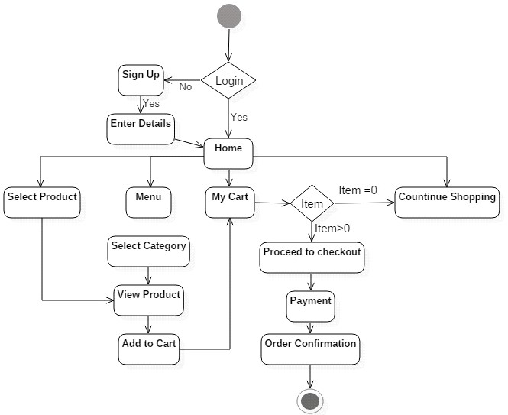

Figure 3.2: Activity Diagram for Online food ordering system

**3.6.2 System Architecture**

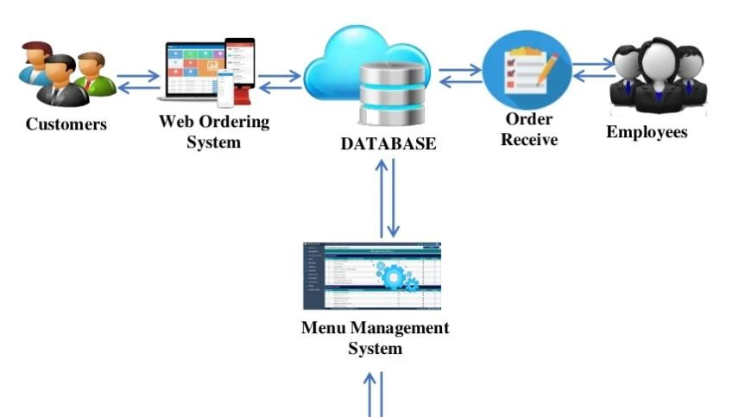

Figure 3.2: System architecture

## 3.6.3 Database Tables/Queries Structures

The database is used to store all information that pertain the food ordering records. Below are the database table for the new system.

**Table 1: Food Table**

Top of Form

| **Name** | **Type** | **Extra** |
| --- | --- | --- |
| id Primary | int(11) | AUTO_INCREMENT |
| name | varchar(250) |  |
| price | varchar(250) |  |
| deleted | varchar(250) |  |

**Table 2: Users table**

**Top of Form**

| **Name** | **Type** | **Extra** |
| --- | --- | --- |
| **id Primary** | int(11 | AUTO_INCREMENT |
| **Name** | varchar(50) |  |
| **role** | varchar(255) |  |
| **username Index** | varchar(50) |  |
| **email** | varchar(50) |  |
| **password** | varchar(50) |  |
| **contact** | bigint(11) |  |
| **address** | varchar(50) |  |
| **verified** | varchar(50) |  |
| **deleted** | varchar(50) |  |

**Table 3: Orders Table**

Top of Form

| **Name** | **Type** | **Extra** |
| --- | --- | --- |
| id Primary | int(11) | AUTO_INCREMENT |
| customer_id Index | varchar(250) |  |
| address | varchar(250) |  |
| description | varchar(250) |  |
| date | varchar(250) |  |
| Payment_type | varchar(250) |  |
| total | varchar(255) |  |
| status | varchar(255) |  |
| deleted | varchar(255) |  |

Bottom of Form

## 3.6.4 Entity Relationship Modelling

An Entity Relationship (ER) Diagram is a sort of flowchart that shows how "entities" in a system, such as people, things, or concepts, interact with one another. ER Diagrams are most commonly used in the disciplines of software engineering, corporate information systems, education, and research to build or troubleshoot relational databases.

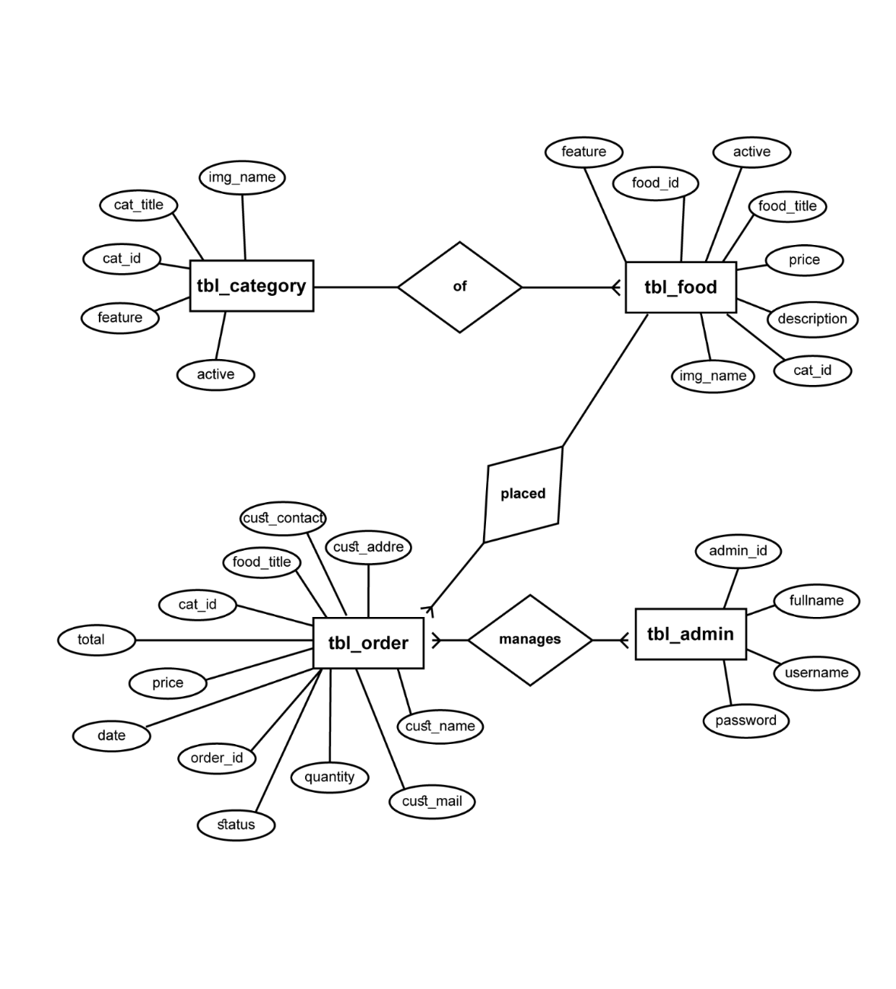

Figure 3.3: Entity Relationship Modelling

## 3.6.5 Database Entity Relationship Diagram

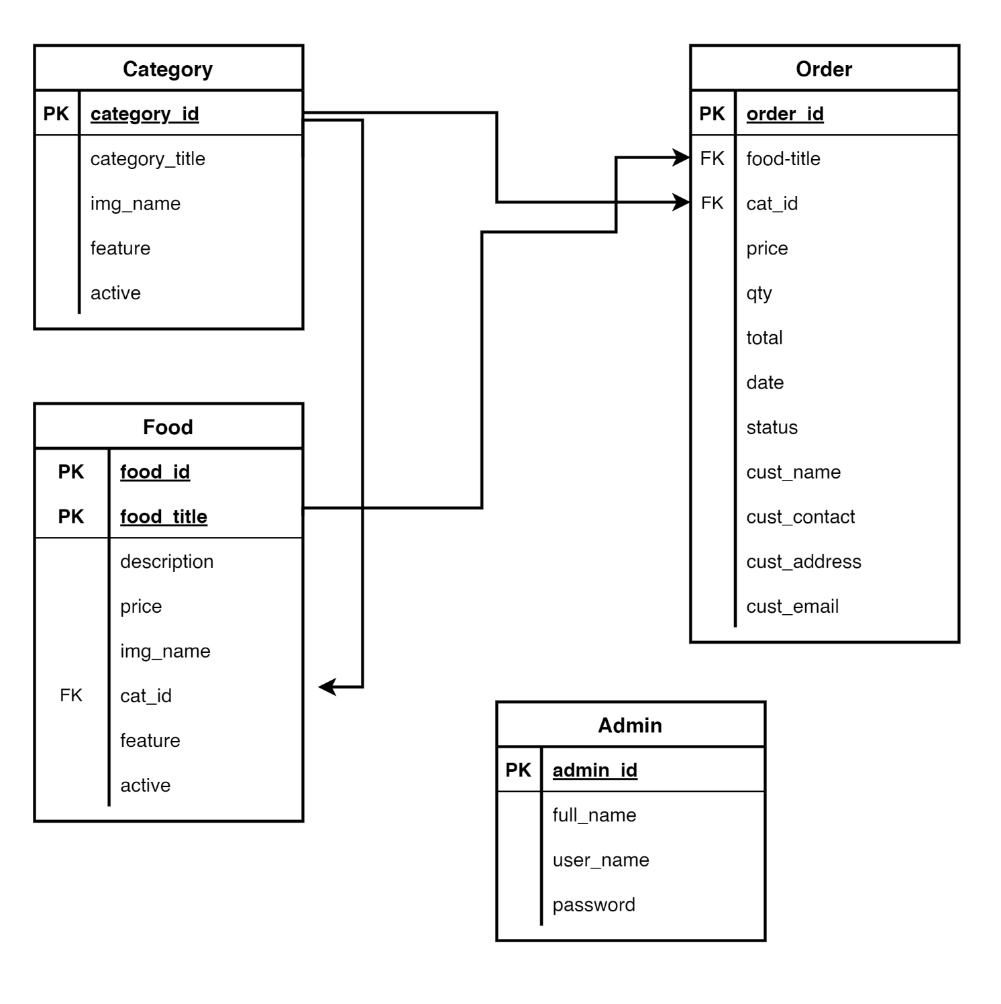

Figure 3.4: Entity Relationship Diagram

## 3.6.6 Input and Output Design

**CUSTOMER REGISTERATION**

Customer Name

Email

**CREATE ACCOUNT**

Phone Number

Password

Already have an account? **Login**

Figure 3.5: Registration Form

**LOGIN FORM**

username

password

**Register Now!**

**LOGIN**

Figure 3.6: Login form

**SELECTED FOOD**

FOOD

IMAGE

**SUBMIT ORDER**

Price/piece

Quantity

Customer name

Email

Delivery Address

Delivery Address

Figure 3.7: Order Form

**PAY WITH**

Card

Bank

Transfer

*# USSD

amir@yahoo.com

Pay **7,000.00**

Use the test bank account provided below to complete this payment

Zenith Bank

2203002930

**Verify Account**

Figure 3.8: Payment Form

## 3.6.7 Report Layout

**ORDERED ITEM(S)**

**Order No.:** 9

**Date**:

**Payment Type:** Wallet

**Address:** Multipurpose Hall, Federal Polytechnic, Mubi

**CANCEL ORDER**

**Status**: Yet to be delivered

**Bottle water** 1 N 200

**Fried Rice** 2 N 1000

**Total**  **N 1200**

Figure 3.9: Ordered Item

## 

## 3.7 System Requirement Specification

## 3.7.1 Hardware Requirements

The software to be design needs the following hardware for an effective operation of the newly designed system.

1. A system running on intel, P(R) duo core with higher processor
2. The-Random Access Memory (RAM) should be at least 512MB.
3. At least 20-GB hard disk.
4. A monitor.

## 3.7.2 Software Requirements

The software requirements include:

1. A window 7 or higher version of operating system.
2. XAMP or WAMP for Database
3. PHP
4. MySQL
5. Browser

## 3.7.3 Personnel Requirement

Any computer literate who has a technical knowhow of internet surfing can use the system because it is user friendly.

# CHAPTER FOUR

# RESULTS AND DISCUSSION

## 4.1 Introduction

The new system is designed using PHP and MySQL programming language for easy records inserting and updating. This system will help in managing and easily retrieving of information from the system for management purposes. The Online Food Ordering System for Amazi Eatery, Federal Polytechnic, Mubi.

## 4.2 Results

## 4.2.1 Login Interface

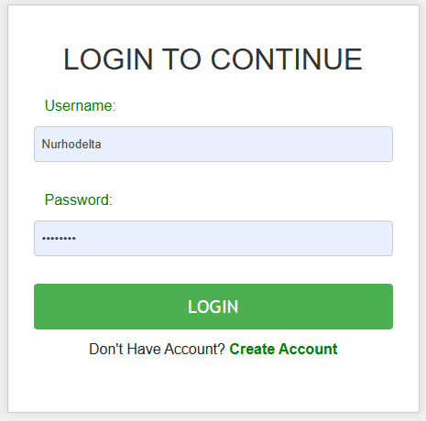

Figure 4.1: Login interface

Figure 4.1 above shows the system login interface. The login interface allows the customers and Administrator to enter their username and password to get access to the system.

## 4.2.2 Admin Dashboard

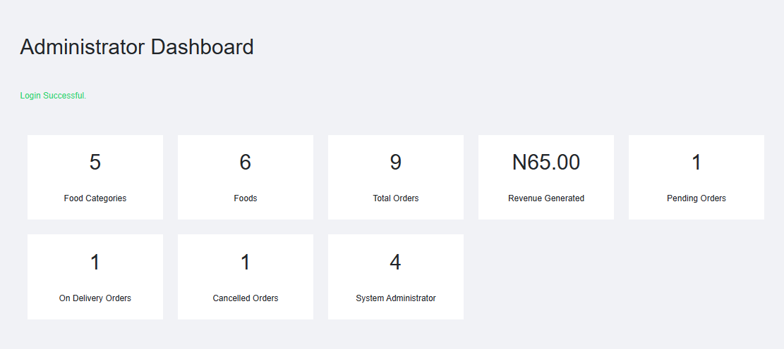

Figure 4.2: Admin Dashboard

Figure 4.2 above shows the system admin dashboard interface. The dashboard interface shows all the tasks that can be performed by the Administrator such as add food items, view reports of orders, update order status etc..

## 4.2.3 Ordered Item Interface

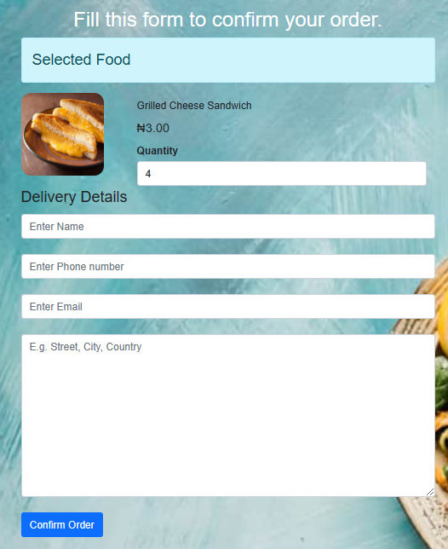

Figure 4.3: Ordered Food Interface

Figure 4.3 above shows the selected food item that a customer wishes to order by filling the order form details like quantity, Name, Address and email.

## 4.2.4 Food Menu Interface

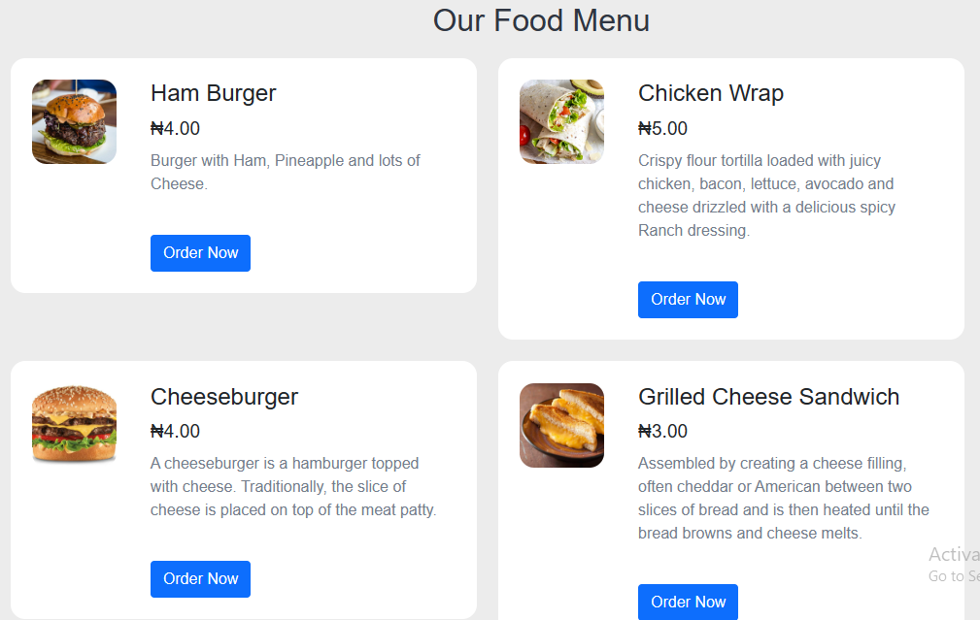

Figure 4.4: Food Menu Interface

Figure 4.4 displays all the available food in the system with their prices where customers can make order from by clicking on the food item so desired.

## 4.2.5 Payment Gateway Interface

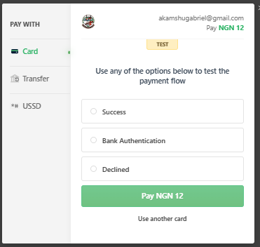

Figure 4.5: Payment Gateway Interface

Figure 4.5 above shows the payment gateway for the food ordering system showing the total payable amount.

## 4.2.6 Ordered Request Interface

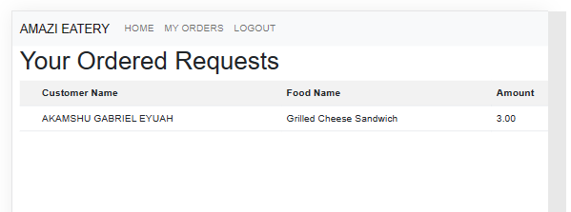

Figure 4.6: Ordered Request Interface

Figure 4.6 above displays all orders made by a particular customer that is logged in, showing the food name, amount, quantity, total and date.

## 4.2.7 Customer Registration Interface

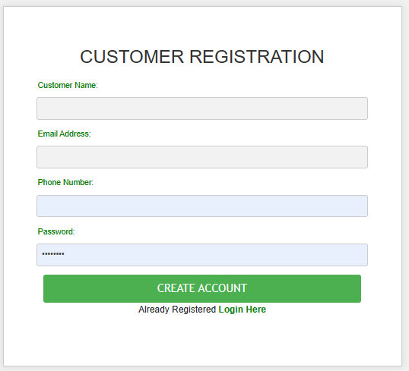

Figure 4.7: Customer Registration Interface

Figure 4.7 this section is used by new customers who do not have an account with the system to create an account in order to be able to make a food order

## 4.3 Discussion

Figure 4.1 represents the Login Interface of the Food Ordering System. It is where users, including customers and restaurant staff, can log in securely using their credentials. The Login Interface ensures that only authorized users can access the system. Customers can view their order history, while restaurant staff can manage orders and update the menu.

Figure 4.2 is a central control panel for restaurant administrators or staff. It provides an overview of system activities and functions. The Admin Dashboard allows administrators to manage orders, monitor customer interactions, update the menu, and analyze performance data, ensuring efficient restaurant operations.

Figure 4.3 illustrates the Ordered Food Interface, where customers can view their current or past orders. The Ordered Food Interface enables customers to track their orders, view order details, and check the order's status, enhancing transparency and customer satisfaction.

Figure 4.4 is the Food Menu Interface is where customers can browse the menu, select items, and place orders. This interface allows customers to explore available dishes, view prices, and customize their orders, facilitating easy food selection and order placement.

Figure 4.5 represents the Payment Gateway Interface, which handles payment transactions securely. The Payment Gateway Interface ensures the secure processing of customer payments. It may include options for various payment methods (credit cards, digital wallets), enhancing convenience and trust.

Figure 4.6 displays ordered requests for restaurant staff to manage and fulfill. The Ordered Request Interface enables restaurant staff to view incoming orders, process them, and update order statuses, ensuring efficient order fulfillment and delivery.

Figure 4.7 shows the Customer Registration Interface is where new customers can create accounts to access the system. This interface facilitates customer registration, allowing users to set up profiles, save preferences, and streamline the ordering process for future transactions.

These interfaces or section of the system collectively depict the various user interfaces and functionalities of the Food Ordering System. They serve different user roles and purposes within the system, ensuring a smooth and user-friendly experience for both customers and restaurant staff. Overall, the system enhances the efficiency of food ordering, delivery, and payment processes, benefiting both customers and the restaurant business.

## 4.4 User Manual

The following are the necessary steps to take in order to use the system efficiently and effectively.

1. Load the url of the system <https://localhost/food/> the welcome page will be displayed.
2. Click on the **Proceed** button to proceed to the main system.
3. If you created an account, provide your login details by entering your username and password.
4. Depending on the login details provided you will be automatically directed to the dashboard.
5. The various task that you can perform on the portal will be displayed on the sidebar of the dashboard.

# CHAPTER FIVE

# SUMMARY, CONCLUSION AND RECOMMENDATIONS

## 5.1 Summary

The "Design and Implementation of a Food Ordering System" for Amazi Eatery at the Federal Polytechnic, Mubi, marks a significant milestone in modernizing foodservice operations. This project aimed to enhance the ordering and delivery process, streamline operations, and improve customer experience. Key components of the system included a user-friendly interface for customers and administrators, order management, and integration with a delivery service.

Through rigorous development and testing, the system was successfully implemented, offering several advantages. It significantly improved operational efficiency by reducing wait times for customers and enhancing order accuracy. Real-time tracking and feedback collection mechanisms contributed to overall customer satisfaction.

The project also contributed to knowledge by highlighting the importance of user-centric design and digital innovation in optimizing restaurant operations. Recommendations were provided to guide the implementation and continuous improvement of Food Ordering Systems in similar establishments.

## 5.2 Conclusion

The successful design and implementation of the Food Ordering System for Amazi Eatery have revolutionized the foodservice experience. It demonstrates the transformative power of technology in addressing the evolving demands of the industry. The system's advantages, including increased efficiency, improved accuracy, and enhanced customer satisfaction, underscore its significance.

The project sets a precedent for the efficient delivery of food services, showcasing the adaptability of technology in catering to dynamic and competitive markets. The success of this system highlights the importance of embracing digital innovation to meet customer expectations and optimize business operations.

## 5.3 Recommendations

Based on our findings and experience with the Food Ordering System, we offer the following recommendations:

1. User Training: Conduct training sessions for restaurant staff to ensure effective use of the system and customer service excellence.
2. Feedback Mechanism: Implement a feedback mechanism within the system to collect input from customers, enabling continuous improvement.
3. Marketing Strategy: Develop a marketing strategy to promote the system and encourage customer adoption.
4. Security Measures: Continuously monitor and update security measures to protect customer data and payment information.
5. Menu Expansion: Regularly update and expand the menu to cater to changing customer preferences and seasonal offerings.

## 5.4 Contribution to Knowledge

This research project contributes to knowledge in the following ways:

It showcases the practical implementation of a Food Ordering System, demonstrating the benefits of digital technology in streamlining restaurant operations.

It emphasizes the importance of user-centered design and the integration of modern technology to optimize customer experience and operational efficiency.

It serves as a case study that can inform other eateries and restaurants seeking to enhance their services through digital innovation.

## 5.5 Area for Further Work

There are several areas for further work and improvement:

Usability Study: Conduct a comprehensive usability study to identify and address any user experience challenges and enhance the system's overall usability.

Integration with Inventory Management: Explore the integration of the Food Ordering System with inventory management to optimize stock control and reduce wastage.

Enhanced Loyalty Programs: Develop and implement customer loyalty programs to reward frequent customers and encourage repeat business.

Waste Reduction Strategies: Investigate strategies to reduce food waste and promote sustainability within the restaurant.

Market Expansion: Consider expanding the system's reach to new markets or delivery areas to increase revenue and customer base.

# REFERENCES

Chen, H., Cai, D., & Zhou, H. (2018). What Determines Customer Satisfaction in Mobile Food Ordering Apps? Evidence from China. *International Journal of Information Management*, 43, 228-242.

Chen, H., Liu, Y., & Liu, J. (2020). Design and Implementation of a Web-Based Food Ordering System. *In 2020 IEEE International Conference on Artificial Intelligence and Computer Applications (ICAICA)*, 21(1), 34-37.

Huang, Z., Li, Y., & Yu, Q. (2019). User Experience Design of Mobile Food Ordering System. *In 2019 IEEE International Conference on Industrial Engineering and Engineering Management (IEEM),* 5(1), 1610-1614.

Hwang, J., & Ryu, K. (2017). The Influence of Food Quality, Service Quality, and Price on Customer Satisfaction and Behavioral Intention in Quick-Casual Restaurants: Moderating Role of Perceived Hygiene Factors. *Journal of Hospitality Marketing & Management,* 26(8), 872-892.

Jang, J., & Namkung, Y. (2009). Perceived Quality, Emotions, and Behavioral Intentions: Application of an Extended Mehrabian-Russell Model to Restaurants. *Journal of Business Research*, 62(4), 451-460.

Kumar, N., Kumar, N., & Khatri, S. K. (2020). Design and Development of Blockchain-Based Online Food Ordering System. *In 2020 2nd International Conference on Advances in Engineering Sciences and Applied Mathematics (ICAESAM)*, 13(2), 1-5.

Li, C., Liu, B., Luo, Y., & Zhang, J. (2021). Design and Implementation of a Food Ordering System Based on Mobile Internet. *In Proceedings of the 2021 5th International Conference on E-commerce, E-Business and E-Government*, 13, 12-17.

Liu, Y., & Li, H. (2020). Exploring the Impact of Customer Satisfaction on Customer Loyalty: A Study of Online Food Delivery Platforms. *Journal of Sustainability,* 12(23), 10165.

Luo, Y., Du, J., & Zhang, J. (2019). The Impact of Customer Satisfaction on Customer Loyalty: A Study of the Online Food Ordering Platforms. *In 2019 5th International Conference on Management Science and Industrial Engineering (MSIE),* 12, 154-158.

Ma, Y., Xia, L., & Zhou, Y. (2022). Design and Implementation of an Online Food Ordering System. *In 2022 IEEE 3rd International Conference on Big Data, Artificial Intelligence and Internet of Things Engineering (BAIIE),* 17, 361-365.

Nguyen, T., & Nguyen, T. (2020). Factors Influencing Customer Satisfaction and Loyalty in Third-Party Food Delivery Apps: A Case of Vietnam. *Journal of Open Innovation: Technology, Market, and Complexity*, 6(3), 75.

Wang, H., Zhao, C., & Du, R. (2020). Design and Implementation of a Mobile Food Ordering System Based on WeChat. *In 2020 IEEE 4th Information Technology, Networking, Electronic and Automation Control Conference (ITNEC),* 15, 2567-2570.

Wu, Y., Zeng, Z., Li, J., & Huang, X. (2021). Design and Implementation of a Kitchen Coordination System for Online Food Ordering. *In Proceedings of the 2021 5th International Conference on Big Data, Artificial Intelligence and Internet of Things Engineering*, 73-79.

Zhang, Z., Li, J., Xu, Z., & Liu, H. (2021). Design and Implementation of an Intelligent Chatbot for Food Ordering System. *In 2021 IEEE 5th Information Technology, Networking, Electronic and Automation Control Conference (ITNEC),* 3063-3067.

# APPENDIX A

**Login Interface**



**Admin Dashboard**



**Ordered Request Interface**



**Ordered Item Interface**



**Food Menu Interface**



**.**

**Payment Gateway Interface**



**Customer Registration Interface**



**APPENDIX B**

**PROGRAM CODE**

<!DOCTYPE html>

<html lang="en">

<head>

  <meta charset="UTF-8">

  <!-- Important to make website responsive -->

  <meta name="viewport" content="width=device-width, initial-scale=1.0">

  <title>Online Food Order System</title>

  <!-- Link our CSS file -->

  <link rel="stylesheet" href="css/style.css">

  <link href="https://cdn.jsdelivr.net/npm/bootstrap@5.0.2/dist/css/bootstrap.min.css" rel="stylesheet" integrity="sha384-EVSTQN3/azprG1Anm3QDgpJLIm9Nao0Yz1ztcQTwFspd3yD65VohhpuuCOmLASjC" crossorigin="anonymous">

</head>

<body>

  <nav class="navbar navbar-expand-lg navbar-light bg-light">

    <div class="container-fluid">

      <a class="navbar-brand" href="#">AMAZI EATERY</a>

      <button class="navbar-toggler" type="button" data-bs-toggle="collapse" data-bs-target="#navbarNav" aria-controls="navbarNav" aria-expanded="false" aria-label="Toggle navigation">

        <span class="navbar-toggler-icon"></span>

      </button>

      <div class="collapse navbar-collapse" id="navbarNav">

        <ul class="navbar-nav ml-auto"> <!-- Use ml-auto to align the links to the right -->

          <li class="nav-item">

            <li class="nav-item"><a class="nav-link" href="inde.php">HOME<span>  </span></a></li><li class="nav-item"><a class="nav-link" href="customer.php">MY ORDERS<span>  </span></a></li><li class="nav-item"><a class="nav-link" href="logout.php">LOGOUT</a></li>          </li>

        </ul>

      </div>

    </div>

  </nav>

  <div class="clearfix"></div>

  <!-- Navbar Section Ends Here -->

    <!-- fOOD sEARCH Section Starts Here -->

    <section class="food-search2">

        <div class="container">

            <h2 class="text-center text-white">Fill this form to confirm your order.</h2>

            <form action='payment/pay.php' method="POST" class="order">

                <fieldset>

                    <legend class="alert alert-info">Selected Food</legend>

                    <div class="food-menu-img">

                                                        <img src="http://localhost/food/onlinefood/images/food/Food-Name-3461.jpg" alt="Chicke Hawain Pizza" class="img-responsive img-curve">

                    </div>

                    <div class="food-menu-desc">

                        <h3></h3>Chicken Wrap</h3>

                        <input class="form-control" type="hidden" name="food" value="Chicken Wrap">

                        <p class="food-price">&#8358;5.00</p>

                        <input class="form-control" type="hidden" name="price" value="5.00">

                        <div class="order-label">Quantity</div>

                        <input class="form-control" type="number" name="qty" class="input-responsive" value="1" required>

                    </div>

                </fieldset>

                <fieldset>

                    <legend>Delivery Details</legend>

                    <input class="form-control" type="text" name="full-name" placeholder="Enter Name" class="input-responsive" required><br>

                    <input class="form-control" type="tel" name="contact" placeholder="Enter Phone number" class="input-responsive" required><br>

                    <input class="form-control" type="email" name="email" placeholder="Enter Email" class="input-responsive" required><br>

                    <textarea class="form-control" name="address" rows="10" placeholder="E.g. Street, City, Country" class="input-responsive" required></textarea> <br>

                    <input class="btn btn-primary" type="submit" name="submit" value="Confirm Order" class="btn btn-primary">

                </fieldset>

            </form>

        </div>

    </section>

<!DOCTYPE html>

<html lang="en">

<head>

  <meta charset="UTF-8">

  <!-- Important to make website responsive -->

  <meta name="viewport" content="width=device-width, initial-scale=1.0">

  <title>Online Food Order System</title>

  <!-- Link our CSS file -->

  <link rel="stylesheet" href="css/style.css">

  <link href="https://cdn.jsdelivr.net/npm/bootstrap@5.0.2/dist/css/bootstrap.min.css" rel="stylesheet" integrity="sha384-EVSTQN3/azprG1Anm3QDgpJLIm9Nao0Yz1ztcQTwFspd3yD65VohhpuuCOmLASjC" crossorigin="anonymous">

</head>

<body>

  <nav class="navbar navbar-expand-lg navbar-light bg-light">

    <div class="container-fluid">

      <a class="navbar-brand" href="#">AMAZI EATERY</a>

      <button class="navbar-toggler" type="button" data-bs-toggle="collapse" data-bs-target="#navbarNav" aria-controls="navbarNav" aria-expanded="false" aria-label="Toggle navigation">

        <span class="navbar-toggler-icon"></span>

      </button>

      <div class="collapse navbar-collapse" id="navbarNav">

        <ul class="navbar-nav ml-auto"> <!-- Use ml-auto to align the links to the right -->

          <li class="nav-item">

            <li class="nav-item"><a class="nav-link" href="inde.php">HOME<span>  </span></a></li><li class="nav-item"><a class="nav-link" href="customer.php">MY ORDERS<span>  </span></a></li><li class="nav-item"><a class="nav-link" href="logout.php">LOGOUT</a></li>          </li>

        </ul>

      </div>

    </div>

  </nav>

  <div class="clearfix"></div>

  <!-- Navbar Section Ends Here -->

    <!-- fOOD sEARCH Section Starts Here -->

    <section class="food-search text-center">

        <div class="container">

            <form action="http://localhost/food/onlinefood/food-search.php" method="POST">

                <input type="search" name="search" placeholder="Search Foods" required>

                <input type="submit" name="submit" value="Search" class="btn btn-primary">

            </form>

        </div>

    </section>

    <!-- fOOD sEARCH Section Ends Here -->

    <!-- CAtegories Section Starts Here -->

    <section class="categories">

        <div class="container">

            <h2 class="text-center">Explore Various Food Categories</h2>

                        <a href="http://localhost/food/onlinefood/category-foods.php?category_id=11">

                <li>

                    <a href="#"><img src="https://img.icons8.com/fluent/50/000000/facebook-new.png"/></a>

                </li>

                <li>

                    <a href="#"><img src="https://img.icons8.com/fluent/48/000000/instagram-new.png"/></a>

                </li>

                <li>

                    <a href="#"><img src="https://img.icons8.com/fluent/48/000000/twitter.png"/></a>

                </li>

            </ul>

        </div>

    </section>

    <!-- social Section Ends Here -->

    <!-- footer Section Starts Here -->

    <section class="footer">

        <div class="container text-center">

            <p>All rights reserved. Designed By Vijay Thapa</p>

        </div>

    </section>

    <!-- footer Section Ends Here -->

</body>

</html>